Send and Save to the Sky Drive from Office 2010

The first time you use this command you will need to login to the SkyDrive. |  |  | 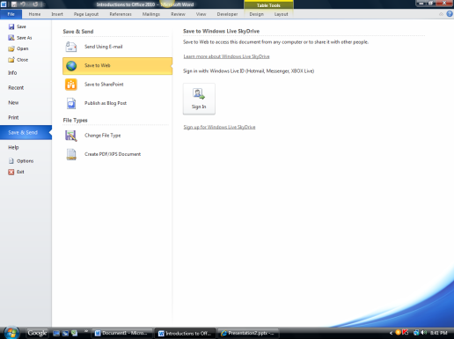
You will need to type in your entire email account that was used to setup this account and then the password. |  |  | 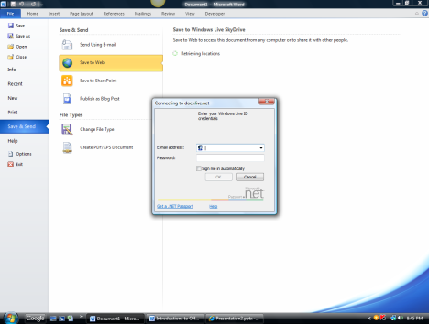
A scree with all your folders will show on the left hand side of the screen.  Choose your folder or create a new folder. |  |  | 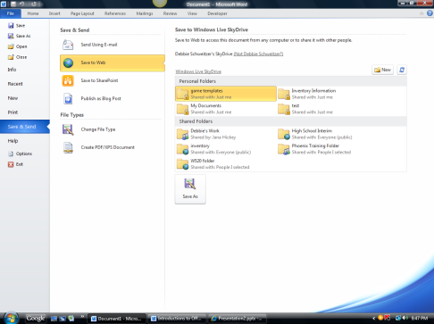
The save As box will appear. |  |  | 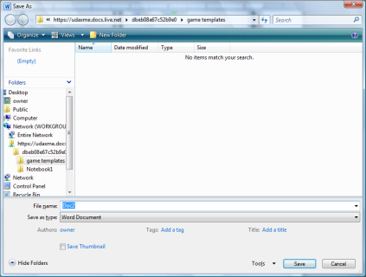
Looking at the save line you can tell it is going to the SkyDrive
Watch at the bottom of the window. You will see the following message. You need to wait until this disappears. It may take a little longer to save than it does to your hard drive or USB drive. Speed depends on your internet speed.

