File Tab or Backstage
Microsoft has revamped and renamed the File menu calling it “Backstage”. This feature is now more accessible than previously. It has been re-born with new features added yet it still has commands like – Save, Save As, Open, Print and Close.
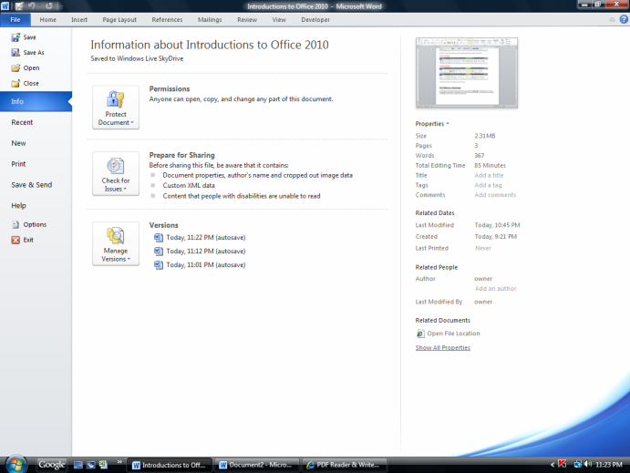 | When you press the File tab, The screen on the left hand side will appear. There are several choices down the left hand side of the screen as you can see in the image on the right hand side. Save, SaveAs, Open, and close are used as usual.  The commands listed under Info are new.
The Recent command will bring up the last 25 files you have worked on in this program.  Recent Places will bring up the last 25 places you have stored those files and will show you the path to get to that place. | 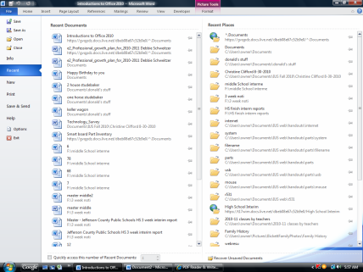
The New command will show templates available to you. When you start the program for the first time this does not show. It only shows when you press this command. | 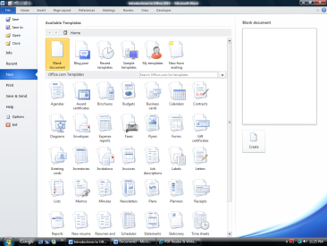
The Print Command also has a new look. The middle column allows you change many settings dealing with how the document will print. The right hand side will show a print preview of the page you are going to print.  You can use the scroll bar to scan up and down of change the percent of the view to see all the pages. | 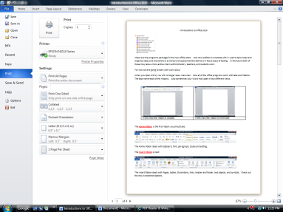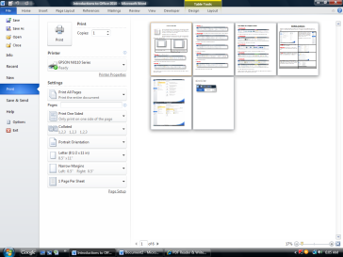
The Send and Save is very new. This will allow you send or save the documents to multiple places other than your hard drive or usb drive.  This is where can save documents to the Sky Drive. | 