Share a Folder or File on the SkyDrive
Share a Folder
Once in the folder you can use the drop down menu under share.  NOTE:  If you want the folder to appear on the left hand side then you need to go to your profile and make that person a friend first.  If you want to just share only, this will come through your email and the person you shared with must always go to their email account to open. | 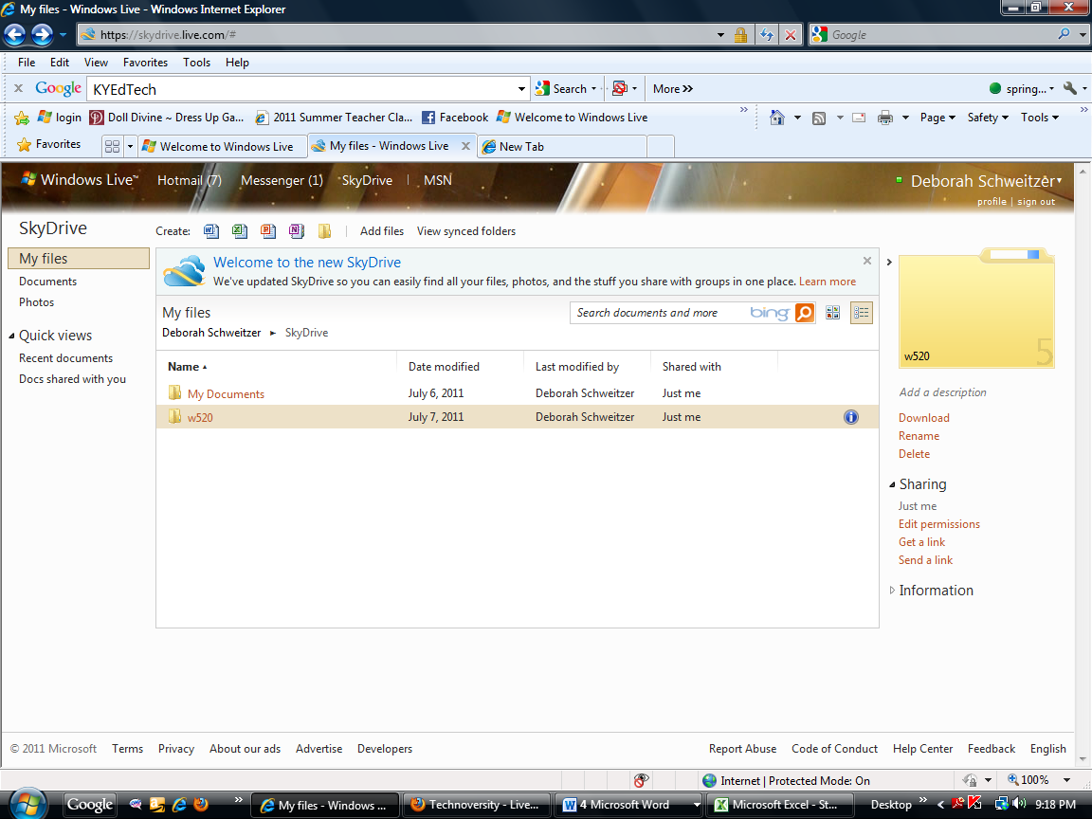
If you click on Share permissions you can determine how much you will allow someone to assess or edit your file. | 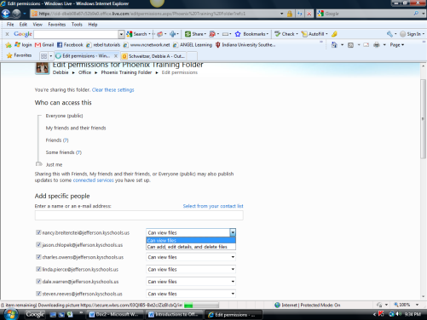
Under send a link, you can send a link to someone you know. You can write a message to go with the link. You can also require the recipients to have a w Window live ID to access the file.
I can also create a link to send on your own.
Share a file
Look at the list of files. When the mouse rolls over the file name a menu will appear and Edit permissions and Send a link are the choices.

It works the same as the folders.

