Creating and Adding Files to the SkyDrive
On the main page you can click on NEW and create a new folder.
Click on your file folder to open it. |  | open  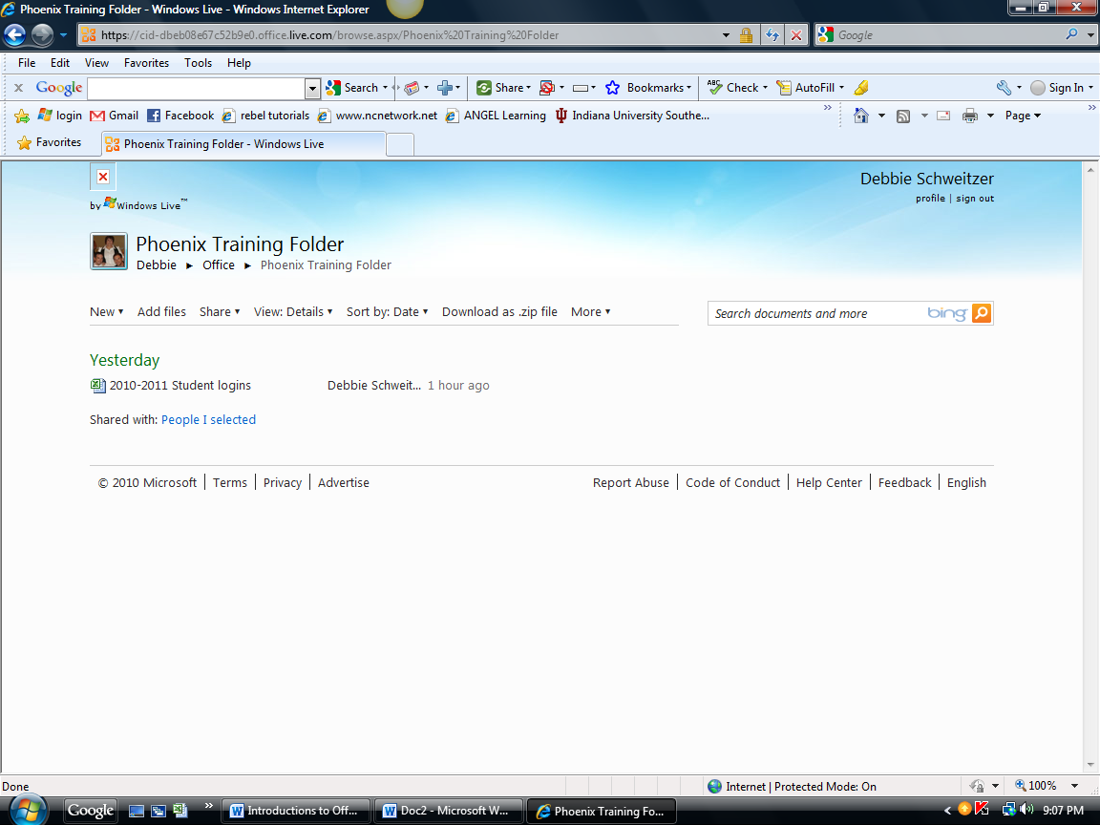
In the folder there are commands at the top that will allow you to do different things.
If you click on the Add button, you can actually drag files off your computer’s hard drive on to the SkyDrive.  This can be any type of file. It does not have to be an Office file. |  | 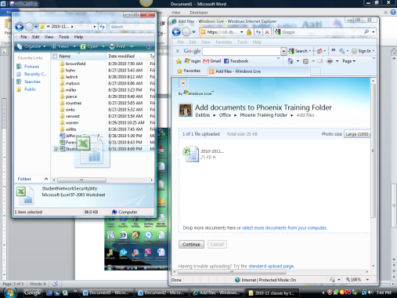
You can see the document as it uploads.

